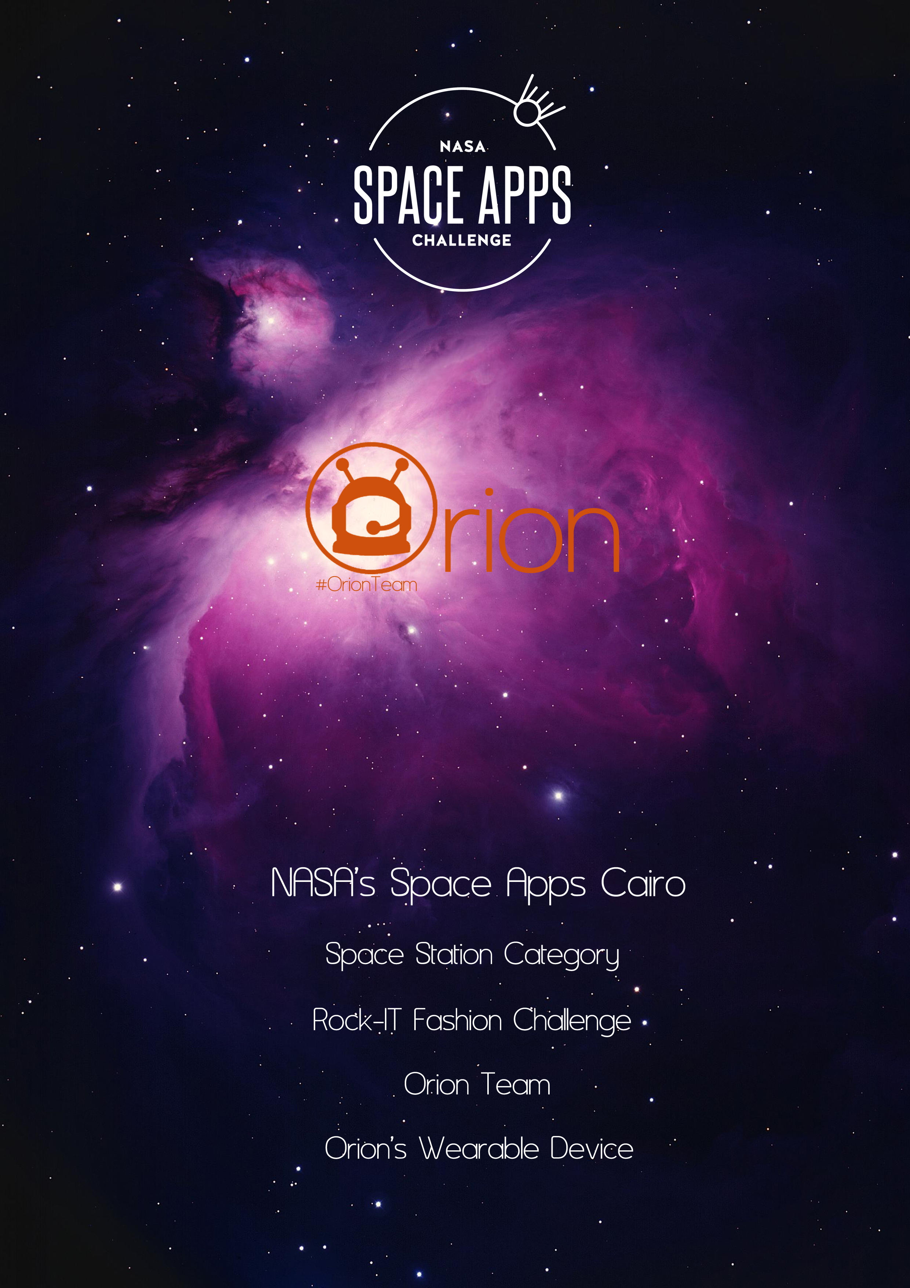

Table of content

I. Introduction 3

II. Our System 4

a. Hardware System 4

1- Raspberry Pi2 Micro-Computer. 4

2- HDMI Touch Screen 5” for the raspberry pi Micro-Computer . 4

3- Arduino Nano – Micro-Controller.. 4

4- Heart Rate Sensor. 4

i. Understanding the ECG 5

ii. PR Interval 6

iii. QT Interval 7

5- **Temperature sensor**  8

6- **Pressure sensor** 8

7- **IMU (Inertial measurement unit)**  8

**8-** **HD-Web-Camera 720p (Microsoft 3000 HD)** 8

b. Software System. 8

1- Space Station Software. 8

2- Wearable Device Software 9

3- Arduino Code 10

c. Communication System 10

d. Power System 10

e. Wearable Fashion Design 11

III. Future work 12

IV. Files 12

NASA’s Space Apps Cairo   
Space Station Category   
Rock-IT Fashion Challenge  
Project: Orion’s Wearable Device

1. Introduction

An Integrated  Smart Wearable Device that can solve the challenge of space station – Rock-IT Fashion ; which helps astronauts to Communicate with their team in the space station using HD Real-Time live Streaming over internet (Wi-Fi ) , Text-Chat , warning messages using (ZigBee 802.15.4) protocol (wide range ) , Monitoring Health Status using Real-Time Monitor for Heart Pulses , Temperature and pressure Sensors which send its data to (C# Software on the space-station using ZigBee communication protocol furthermore show this rates to the astronauts on the LCD using python GUI ( Graphical user Interface) on the raspberry pi 2 Micro-Computer ;   
for Entertainment using our device astronauts can connect with the internet and social Networks like what Nasa’s Astronaut “Scott Kelly “ did during his “year in space” journey  , Astronauts can play Games , Videos .  
- All Astronauts Data that our system collect saved as a log file on the device and on the space station software with date and time, this Big data can be analyzed with the software tools commonly used as part of advanced analytics disciplines such as predictive analytics, data mining . as a part of our future plan to improve our device , it will be an autonomous Device which use the analyzed data to make an action such as sending a specific music to the astronaut which suitable with his mood , health status .

Hint : using electronics in space is not reliable due to the radiation , but any electronics material in space have to pass 7-Layers of testing to be reliable in space , such as the electronics devices that GOMSPACE company offering for Cube-Sats.

Our system is divided into 5 Main Sub-systems:  
1- Hardware System: Sensors, Hardware components.   
2- Software System: Space Station Software for communication and data accusation – Wearable device software for the astronauts.

3- Communication System.  
4- Power System.

5- Wearable Fashion Design .

1. Our System
2. Hardware System
3. Raspberry Pi2 Micro-Computer which has A 900MHz quad-core ARM Cortex-A7 CPU , 1GB RAM , VideoCore IV 3D graphics core .
4. HDMI Touch Screen 5” for the raspberry pi Micro-Computer .
5. Arduino Nano – Micro-Controller that interact with the sensors and send data to the space station and wearable device software GUI .
6. Heart Rate Sensor   
   Studies have shown that spaceflights impacts the astronauts heart rates negatively especially on long term so heart rate is monitored using heart rate sensor (ECG) where the heart pulses is presented using the cardiogram in real-time.
7. Understanding the ECG

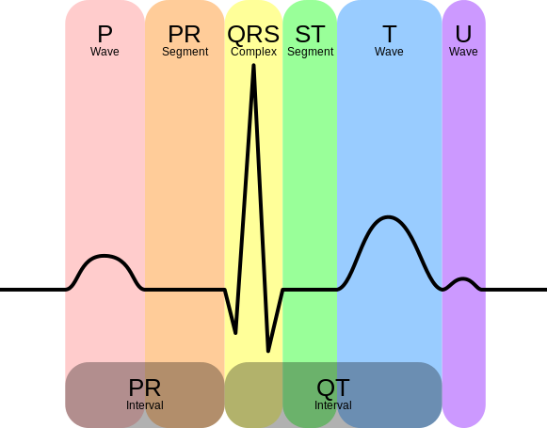  
In general terms, let’s look at what an ECG is representing and how we’re able to sense it. The ECG is separated into two basic Intervals, the PR Interval and the QT Interval, described below.

Figure 1 – Heart Pulses ECG

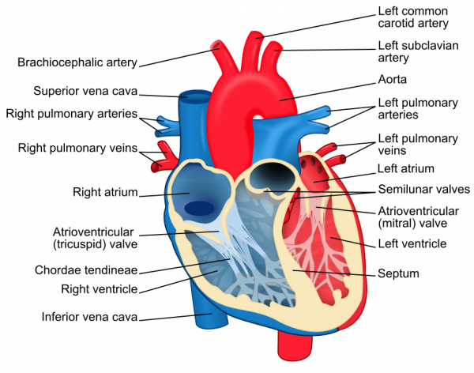

Figure 2 – Heart Diagram

1. PR Interval

The PR interval is the initial wave generated by an electrical impulse traveling from the right atrium to the left. The right atrium is the first chamber to see an electrical impulse. This electrical impulse causes the chambers to “depolarize”. This forces it to contract and drain deoxygenated blood from both the Superior and Inferior vena cava into the right ventricle. As the electrical impulse travels across the top of the heart it then triggers the left atrium to contract. The left atrium is responsible for receiving newly oxygenated blood from the lungs into the left ventricle via the left and right pulmonary veins. The pulmonary veins are red in the diagram because they are carrying oxygenated blood. They are still called veins because veins carry blood towards the heart. Science!

1. QT Interval

The QT Interval is where things get really interesting. The QRS is a complex process that generates the signature “beep” in cardiac monitors. During QRS both ventricles begin to pump. The right ventricle begins to pump deoxygenated blood into the lungs through the left and right pulmonary arteries. The pulmonary arteries are blue in the diagram because they are carrying deoxygenated blood. They are still called arteries because arteries carry blood away the heart. Science, Again! The left ventricle is also beginning to pump freshly oxygenated blood through the aorta and into the rest of the body. After the initial contraction comes the ST segment. The ST segment is fairly quiet electrically as it is the time where the ventricles waiting to be “re-polarized”. Finally the T wave becomes present to actively “re-polarize”, or relax the ventricles. This relaxation phase resets the ventricles to be filled again by the atriums.

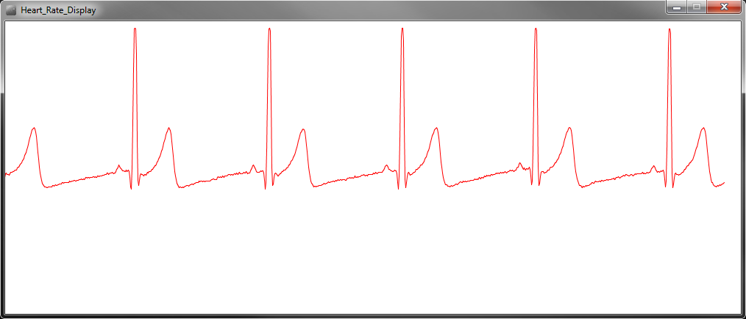

1. **Temperature sensor** Astronauts are exposed to a wide variety of temperature during their missions which can range from -250F to 250F so a temperature sensor is used to monitor the temperature and gives a warning message when necessary.
2. **Pressure sensor ,** one of important concerns of the factors which impacts the health of the astronaut is that the increased pressure in the eye may cause what is called “Ocular hypertension” which causes problems in the vision and may lead to blindness so a pressure sensor is used to keep track of the pressure and gives a warning message if the pressure exceeds a certain limit.
3. **IMU (Inertial measurement unit) –** 9DOF – Accelerometer, gyroscope, Magnetometer.   
     
   in our plan of future work we added IMU in order to develop a games like Smart phones apps which depends on gyroscope , Accelerometer sensors .
4. **HD-Web-Camera 720p (Microsoft 3000 HD)**

Which has the ability to stream a real-time video with delay 40 ms with 30 frame per second through Wi-Fi dongle that connected to raspberry pi micro-computer and works as a webcam server over localhost (raspberry pi ip port 8080 ) .

1. Software System.
2. Space Station Software.

The main aim of our GUI is to provide the space station with a live feed of the current astronaut status in order to ensure a total supervision over the astronaut and monitor his current

Health condition in addition to providing an easy and simple means of communication with the astronaut.

GUI Features:

* + Health monitoring:
    - Monitoring the heart statues via a live cardiogram.
    - Live feed for the current temperature.
    - Live feed for the current pressure.
  + GUI provides warning messages if the temperature or the pressure exceeds certain limits.
  + Ease of communication support:
  + Providing a high quality live streaming for the camera fixed on the astronaut suit.
  + Chat facility between the space station and the astronaut via the GUI on the astronaut wearable.
  + All the received data, received and sent chat messages are logged and displayed in a user friendly way accompanied by the corresponding date and time.
  + Saving all data as txt log files.

1. Wearable Device Software

A GUI programmed by Python that allow Astronauts to show their health status, sensors reads with options of Chat, on-screen keyboard, keystroke software that save all astronauts keyboard inputs on the screen, option to start live streaming.

- Saving all data as excel log files .  
- This application also contains bash script to run the required packages in boot.

1. Arduino Code

Interfacing code with the sensors and ZigBee module to send a the data in a way of serial communication with Raspberry pi “wearable software through usb cable “ and Space station software by ZigBee Ad-hock network .

1. Communication System

* Usb Serial Communication between Arduino and Raspberry pi.
* ZigBee Ad-hock Network Serial Communication with Arduino and space station software.
* Wi-Fi Connection between Raspberry pi and Router ( over Network ) || internet .

1. Power System

We are powering our system using 5000 mah battery with output current up-to 2A which is very enough for our system to run more than 2-hours .

1. Wearable Fashion Design

Using two armbands with us to contain our project in a nice-look way .

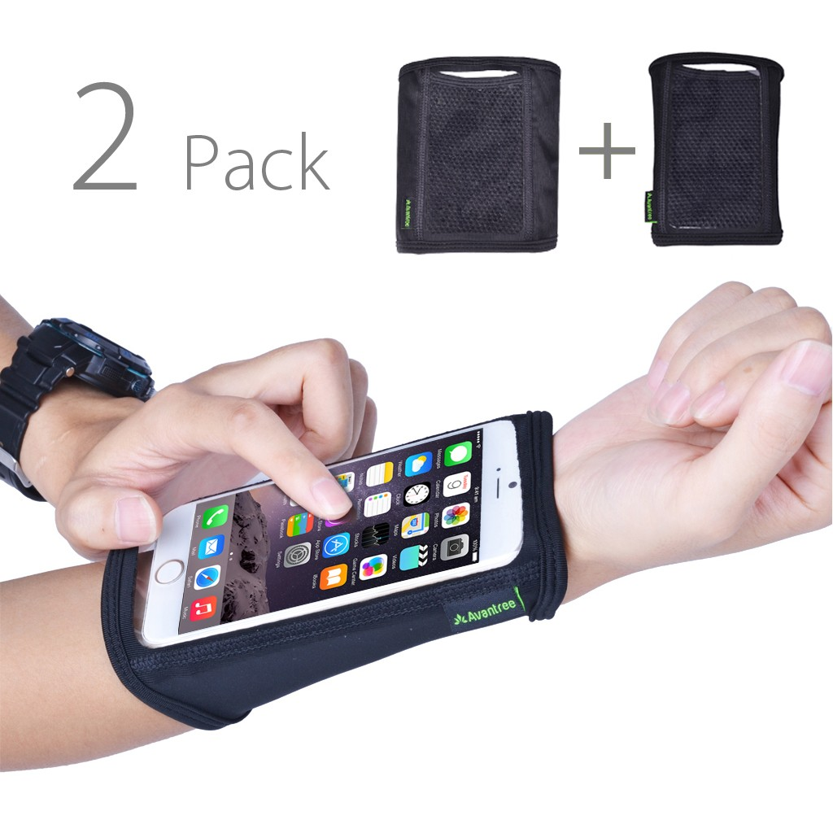

Figure – Armbands

1. Future work
2. Size and Design , Decrease size , use embedded devices not educational kits .
3. Big Data Analytics and statistics.
4. Autonomous System – Machine learning .
5. Astronauts profiles.
6. Motion Detection Flex sensors, as a new way of control our system without using touchscreen.
7. improve GUI .
8. IMU Sensor Based Games .
9. Files

To get our soft copy of our documentation and files , codes from the link below :   
https://github.com/Orionteamnsac/Orion-s-Wearable-Device-  
||  
http://www. Orion.16hexa.com